CLASSROOM OLYMPIAD PROBLEMS – SET ONE

PROBLEM ONE - SET ONE
Sam picked four numbers out of a hat. The mean average of the four numbers is 9.

If three of the numbers are 5, 9 and 12, then what is the fourth number?

PROBLEM TWO - SET ONE

An unusual die has six faces labeled 1, 2, 3, 5, 7 and 8. If two of these dice are rolled, and the numbers showing on the upper faces are added, what is the number of possible different sums?

PROBLEM THREE - SET ONE
If $\frac{2}{3}$ of a cup of fish food can feed 10 goldfish, then 4 cups of fish food should be able to feed how many goldfish?

PROBLEM FOUR - SET ONE

Jenna and her Mom are taking part in Halifax’s 60 km Walk for a Cure, a fundraiser for the fight against breast cancer. Jenna brings along her dog Lucky. They leave at 9:00 am, Jenna is walking at a speed of 7 km/h and her Mom is walking at a speed of 10 km/h. Lucky is running at a speed of 12km/h. After a few minutes into the walk, Lucky starts running back and forth between Jenna and her Mom, still keeping a speed of 12 km/h.

After 3 hours how many kilometers will Lucky have run?

PROBLEM FIVE - SET ONE
Jacob made $8500 playing basketball over the last two weeks. He played six basketball games that were one and a half hours long last week, and four basketball games that were two hours long the week before.

How much money does Jacob make playing basketball per hour?

CLASSROOM PROBLEMS
SET ONE
ANSWER KEY

- 10

- 15

- 60

4. 36

5. 500

CLASSROOM OLYMPIAD PROBLEMS – SET TWO


PROBLEM ONE - SET TWO
Two gear wheels A and B are in contact. Wheel A has 36 teeth and B has 24 teeth.

How many more times must the smaller wheel turn before the larger wheel completes a revolution?

Problem TWO - SET TWO
Mrs. Smith teaches guitar. Sarah, her student, does not like to practice. Mrs. Smith promises Sarah a new guitar pick once she has completed a total of 2 hours practice.
Sarah practices 8 minutes the first night, 16 minutes the second night, 24 minutes the third night and so on until she has practiced a total of 2 hours.

How many nights did it take Sarah to reach her goal?


PROBLEM THREE - SET TWO
The ferry to Newfoundland leaves Sydney, Cape Breton at 10:27 pm on Tuesday.
The ferry takes 13 hours and 46 minutes to arrive in Argentia, Newfoundland.
What time will it be when the ferry arrives on Wednesday? (Be sure to specifiy AM or PM.)


PROBLEM FOUR - SET TWO
Your pet bunny has always been slightly crazy. Lately, though, he’s started shoplifting carrots from grocery stores! Bunny Obedience School hasn’t worked. You decide to build a bunny pen.
You want to build a rectangular pen that is 16 meters by 20 meters by spacing the posts of your fence 4 meters apart from each other.

How many fence posts will you need?

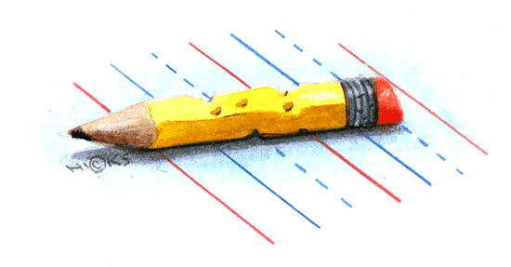
Problem FIVE - SET TWO

The number 525 can be written as the product of two odd integers each greater than 1.

IN HOW MANY WAYS CAN THIS BE DONE?

CLASSROOM PROBLEMS
SET TWO
ANSWER KEY

- 1.5 OR 1 ½

- 5

3. 12:13 PM

4. 18

5. 5

EXTRA CLASS PROBLEM - 1
These figures    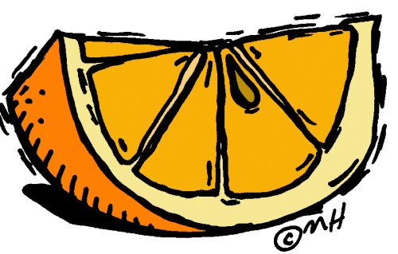 

are repeated in a sequence like the following:

….

WHAT IS THE 214th FIGURE IN THIS SEQUENCE (CHOOSE A Letter):

A) B) C) D) E)

SOLUTION
Since the pattern repeat itself after every five figures, it begins again after 210 figures have been completed. The 214th figure in the sequence is the fourth figure in (D):

(D)

EXTRA CLASS Problem -2
A side of the equilateral triangle A is twice the length of a side of triangle B.
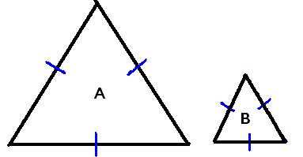

How many triangle B’s will fit into triangle A?

Four triangles B’s will fit into triangle A

